# Overview

This document will show how to enable DevOps practices with Design Studio and T24 using T24 Sandbox

* Build based on GIT + cloud T24 sandbox test environment

**What we should have and is not yet included:**

* Provisioning of a cloud test T24 env at the start of the builds
* Sample TUT test cases
* Sample JUnit test cases
* Sample Selenium test cases

# Pre-requisites

DS:

* <http://p2.oams.com/dist/latest/201704/Promoted/17.0/DesignStudioT24-R17.0.zip>
* Unzip to a local folder, example C:\DS\DesignStudioT24-R17.0

t24-binairies

* [http://p2.oams.com/dist/latest/201704/Promoted/17.0/t24-binaries-R17.0.20170512181108_513c0cb857cc50b78d9a39bd8d095fcb564669fd.zip](%20http://p2.oams.com/dist/latest/201704/Promoted/17.0/t24-binaries-R17.0.20170512181108_513c0cb857cc50b78d9a39bd8d095fcb564669fd.zip)
* Copy to DS folder, example C:\DS\DesignStudioT24-R17.0

JDK

* JDK used by DS or a compatible one (JDK 1.7)
* C:\DS\DesignStudioT24-R17.0\jdk

Maven:

* Maven 3.3.9
* <https://maven.apache.org/download.cgi>

GIT

* <https://git-scm.com/downloads>
* Sample: GIT
* Local install in C:\apps\Git

Temenos T24 Local Install

* <http://utp.temenosgroup.com/Downloads>
* Install the aligned version (R17 AMR @ <http://utp.temenosgroup.com/Downloads/Check?url=http%3A%2F%2Fhemel-ivy.temenosgroup.com%2F%2Fdownloads%2FRelease_UTP_developer_REL-RET-S08-2017.05.18-01-211.zip> )

Jenkins

* Download latest LTS version from <https://jenkins.io/download/>
* Install Jenkins, ensure you have the following plugins:
  + Pipeline
* Manage Jenkins / Global tool configuration

**Note – use JDK 1.7, not 1.8 as shown below.**

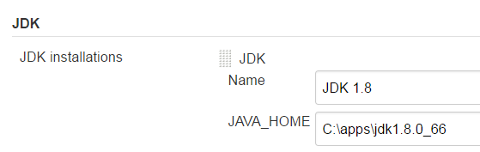

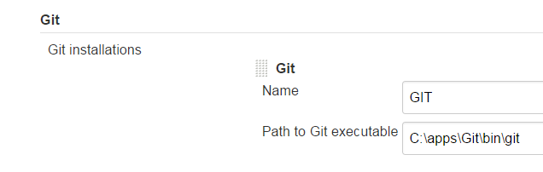

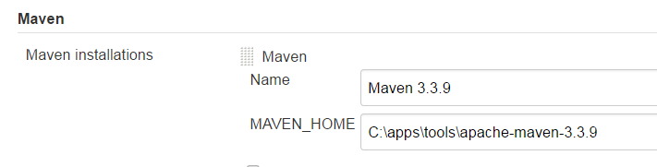

# Cloud based (publish to GitLab)

## Fork repository

For the repository to have your own copy on which you’ll have write access

<https://github.com/mhart013/Prospect-IRIS>

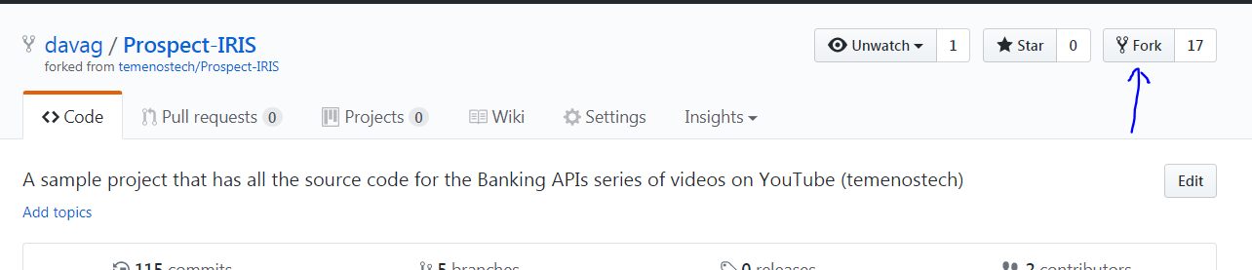

Then adapt all URLS listed later in document.

## Local DS workspace

**Note – before you open Design Studio, make sure you have copied the t24 binaries into the location {path to design studio folder}/t24-binaries**

Start Design Studio, use any workspace path you like. Example: C:\workspace\DS-Packager\t24_sandbox_abn_demo

* Say yes to popup proposing to update t24-binaries (will only be asked once)

Set Maven mode to online -> Menu Window\Preferences

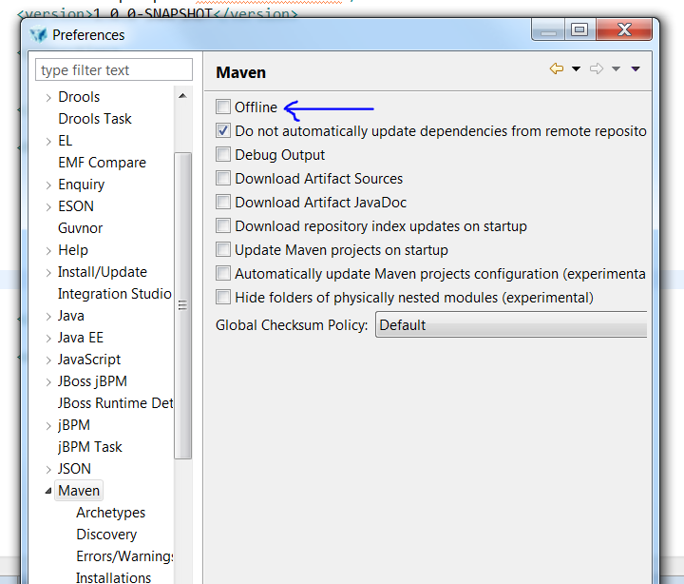

Import project from GIT -> Menu File\Import :

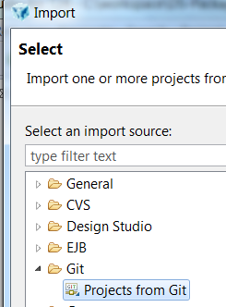

Clone URI

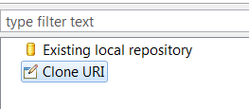

Select repository and a git user id/password

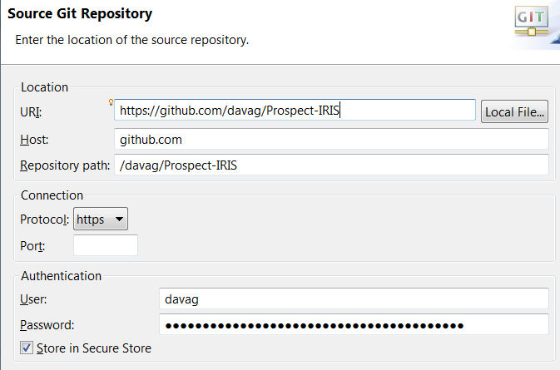

Only demo_ci branch **(note: use demo_ci, not demo_abn as shown below)**

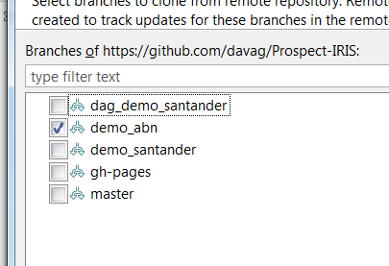

Then click on next and Finish to import existing Eclipse projects (select all)

Add git repository view by typing git repo in quick access text area (close to top right)

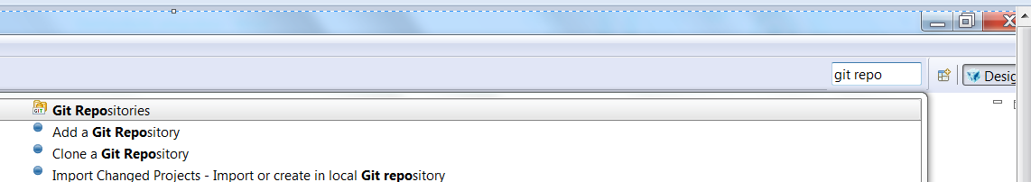

You can move the “Git repositories” window to top left panel:

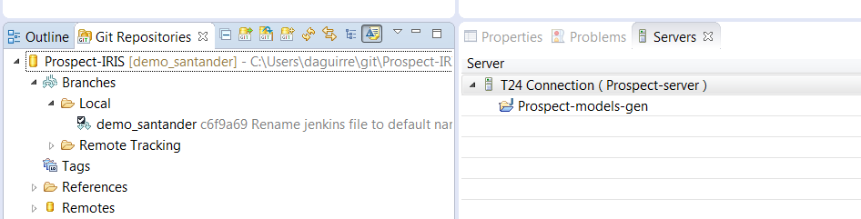

Add “Git staging” view by typing “Git staging” in quick access text area. You can leave the window next to servers

Open Jenkinsfile from GIT working tree

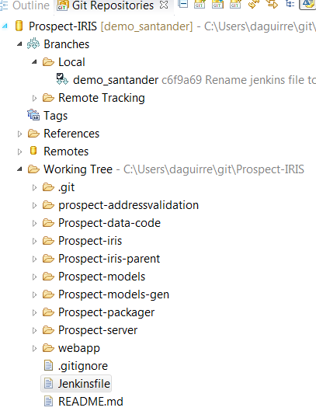

Customize:

* MAVEN_LOCAL_REPO: example: C:/DS/DesignStudioT24-R17.0/t24-binaries
* T24_HOME, TAFJ_HOME and other env variables (point to your locally installed T24 environment)
* T24 Sandbox URL

Move Jenkinsfile to Staged changes and add a commit message and **commit**

* If nothing is shown, click on Prospect-IRIS in Git repositories

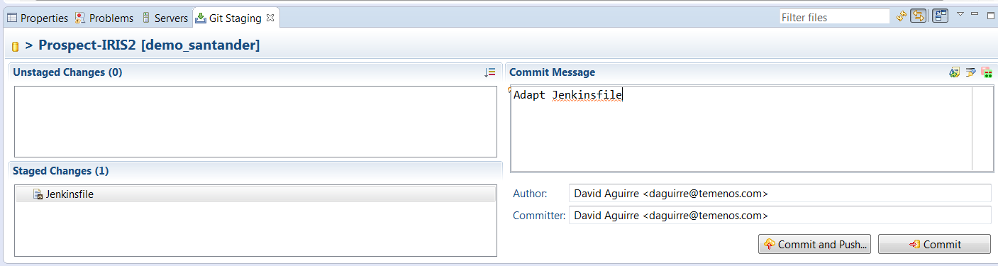

Push your local branch to remote repository (GITHUB) – **note: use demo_ci branch**

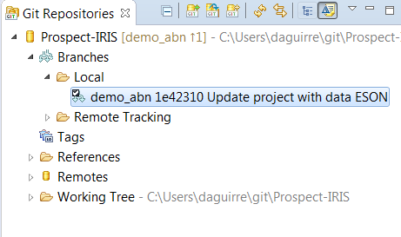

Select rebase commits option + next + finish **note: use demo_ci branch**

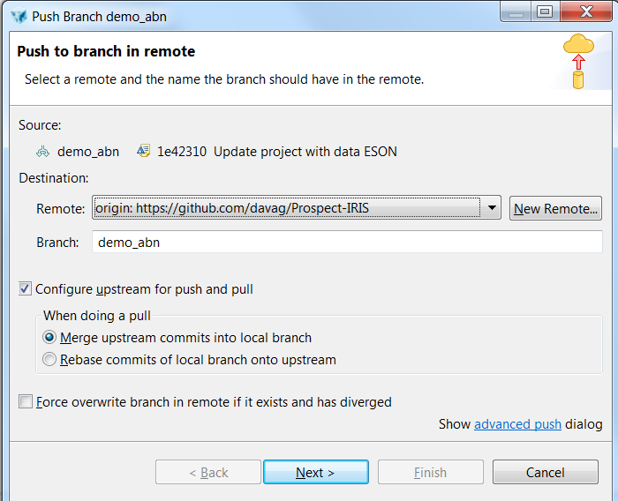

You should now see your commit in <https://github.com/davag/Prospect-IRIS/commits/demo_ci>

Follow this procedure also for any other change (like adding new enquiry, jbc routines, etc…).

## Example Change to make : changing a translation of a field:

Open CUSTOMER,ADDRESS

Navigate to ci-demo-models -> Models -> CUSTOMER,ADDRESS.version

Click on a field (e.g. STREET)

Click on the ‘translations tab’ on the right hand side of the screen

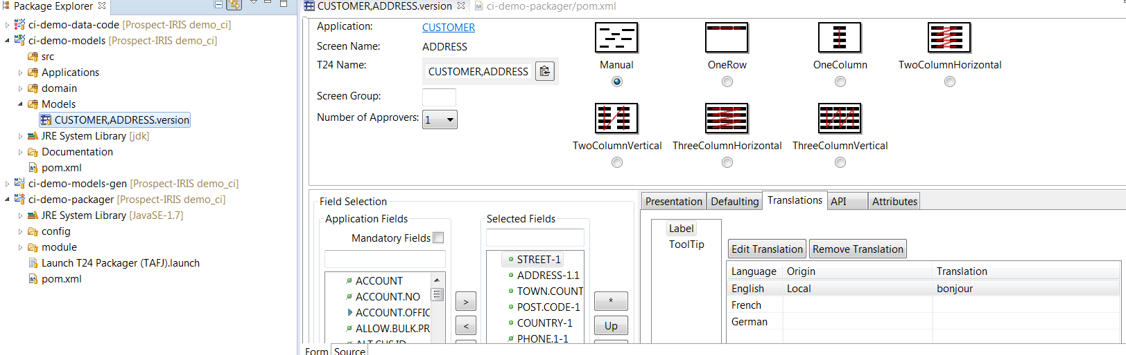

Double click on the ‘English’ translation

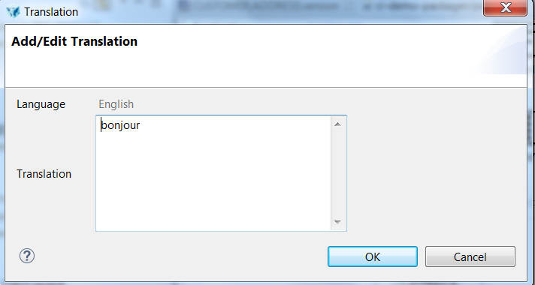

Change the text, save the file CUSTOMER,ADDRESS.version and commit/push the changes as before.

Execute an initial build from within Design Studio to make sure all Maven dependencies are correctly downloaded into your local Maven repo. Perform this build by right clicking on

ci-demo-packager->Launch T24 Packager (TAFJ).launch

Then selecting ‘Run as’, then ‘Launch T24 Packager (TAFJ)

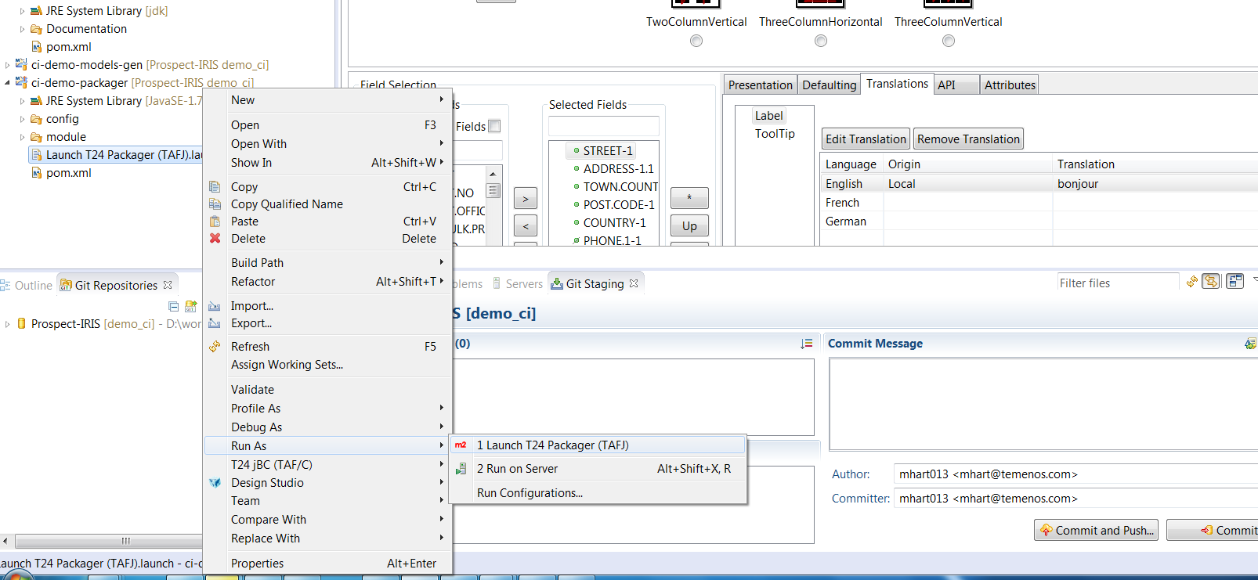

Resolve any build issues before proceeding.

## Setup Jenkins

Create in Jenkins a Pipeline job

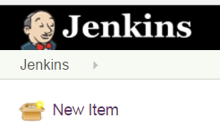



Configure pipeline

For branch-specified, set */demo_ci*

**Note – change the paths below to the paths needed for your forked repo.**

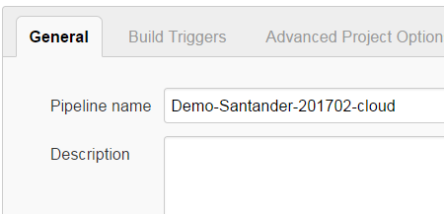

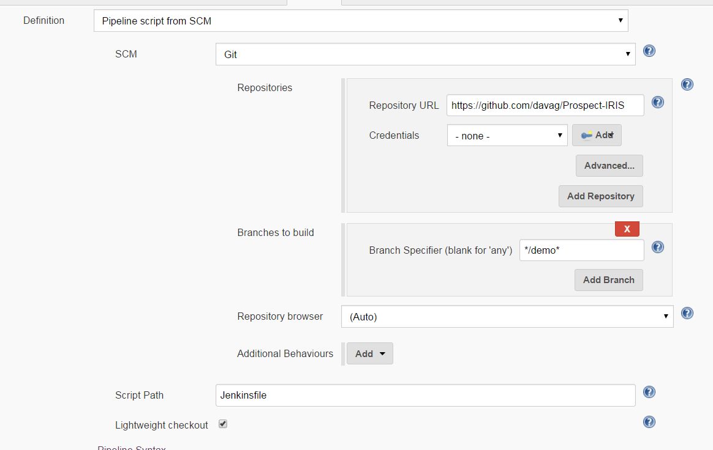

You can now start the pipeline:

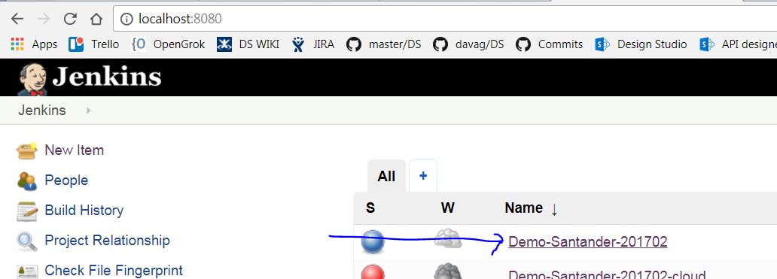

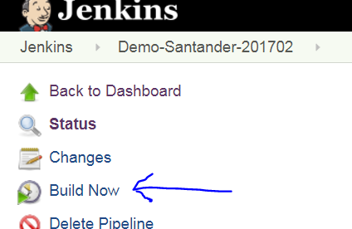

You may need to execute the build twice. The second time it should request an environment ID, which you can manually enter for the build to commit packages to the correct Gitlab repo.

Once published, please check in GitLab that everything worked with a new DS Package

At that point the T24_Pipeline_H2 pipeline on Jenkins will execute, deploying the package on the T24 Sandbox environment.